Development of a CNC System for Material Surface Inscription

Amod Argade
Vishwakarma Institute of Technology
Pune, India
amod.argade22@vit.edu

Pranav Bedekar
Vishwakarma Institute of Technology
Pune, India
pranav.bedekar22@vit.edu

Mangesh Bahir
Vishwakarma Institute of Technology
Pune, India
mangesh.bahir22@vit.edu
Atharva Shinde
Vishwakarma Institute of Technology
Pune, India
atharva.shinde22@vit.edu

Alok Dadhich
Vishwakarma Institute of Technology
Pune, India
alok.dadhich22@vit.edu

Nikita Chavan
Vishwakarma Institute of Technology
Pune, India
nikita.chavan22@vit.edu

Prof. Pramod Kale
Vishwakarma Institute of
Technology
Pune, India
pramod,kale@vit.edu

Abstract- This paper presents the development of a low-cost, miniature Computer Numerical Control (CNC) machine for educational and experimental purposes. The system utilizes an Arduino Uno microcontroller, 28BYJ-48 stepper motors, ULN2003 motor drivers, and readily available hardware components. The mechanical design incorporates 3D printed parts for precise and adaptable construction. The software implementation involves GRBL library for Arduino, Inkscape for image vectorization, and UGS for microcontroller communication. This paper details the hardware and software integration, design considerations, and potential applications of this miniature CNC machine.

Keywords- CNC Machine, Arduino, Stepper Motors, GRBL, Inkscape, UGS, Robotics, Automation, 3D Printing, Education, Mechatronics

- Introduction

Computer Numerical Control (CNC) machines have revolutionized manufacturing by automating production with high precision and repeatability [1]. These machines, following programmed instructions, precisely control tools and workpieces to create intricate designs and components. While industrial CNC machines are sophisticated and expensive, the rise of microcontrollers and open-source hardware has made CNC technology more accessible for education and hobbyist projects [2, 3].

Miniature CNC machines offer a valuable platform for understanding automation, control systems, and computer-aided manufacturing (CAM) [4]. They provide hands-on experience in designing, building, and operating CNC systems, fostering creativity and technical skills. This project focuses on developing a miniature CNC machine using an Arduino Uno microcontroller and readily available components. The goal is to create a low-cost, adaptable system for learning and experimenting with robotics and CNC technology.

This project aligns with the growing emphasis on STEM education and project-based learning [5]. Miniature CNC machines offer an engaging way to learn programming, electronics, mechanics, and design. They empower students to explore their creativity, solve problems, and develop essential skills.

The development of this miniature CNC machine is driven by several key objectives:

Accessibility and Affordability: To create a CNC system accessible to students, hobbyists, and educators with limited budgets by using readily available, low-cost components.

Educational Value: To provide a hands-on learning platform for understanding CNC technology, programming, electronics, and mechanical design.
Adaptability and Customization: To enable users to modify and adapt the CNC machine for various applications and experiments, fostering creativity and innovation.

Open-Source and Replicability: To utilize open-source hardware and software, allowing for easy replication and modification by others, contributing to the maker community.

This project leverages the Arduino Uno's versatility and ease of use, along with the affordability of 28BYJ-48 stepper motors and ULN2003 motor drivers. The mechanical design incorporates 3D printed parts for precision and adaptability. The software implementation utilizes the GRBL library for Arduino for G-code interpretation and motor control. Inkscape is used for image vectorization, and JScut facilitates G-code generation. Finally, UGS (Universal G-code Sender) provides a user-friendly interface for communication and control.

This paper provides a comprehensive overview of the miniature CNC machine's development, including hardware and software components, design considerations, and potential applications in education, hobbyist projects, and experimental research.

- Literature Review

The development of miniature CNC machines has gained significant traction in recent years, fueled by the increasing availability of affordable microcontrollers and open-source hardware and software. Several research studies and projects have explored the design, implementation, and applications of these systems, providing valuable insights and inspiration for this project.
Pabolu and Shrinivas [6] presented the design and implementation of a three-dimensional CNC machine using stepper motors and a microcontroller. Their work highlighted the importance of precise motor control and the use of appropriate software tools for G-code generation and communication. They emphasized the need for careful selection of stepper motors and drivers to achieve the desired accuracy and speed. Their research demonstrated the feasibility of creating a functional 3D CNC machine using readily available components and open-source software, which aligns with the objectives of this project.
Nae and Andrei [7] focused on the design and construction of a CNC router using stepper motors, emphasizing the mechanical aspects and the challenges of achieving accurate and stable motion control. They investigated different types of linear motion systems, such lead screws and linear bearings, and analyzed their performance in terms of accuracy and rigidity. Their findings provide valuable guidance for the mechanical design of the miniature CNC machine in this project, particularly in selecting appropriate linear motion components and ensuring stability.
Pahole et al. [8] investigated the construction and evaluation of a low-cost table CNC milling machine, demonstrating the feasibility of creating functional CNC systems with readily available components. They explored the use of recycled materials and readily available tools to minimize the cost of construction, making CNC technology more accessible to hobbyists and educators. Their approach to utilizing readily available and low-cost materials resonates with the accessibility and affordability objectives of this project.
D'Ausilio [9] explored the use of Arduino as a low-cost and multipurpose lab equipment, showcasing its potential for various applications in education and research. They demonstrated the use of Arduino for data acquisition, control, and automation in various scientific experiments, highlighting its versatility and ease of use. Their work reinforces the choice of Arduino Uno as the microcontroller platform for this project, given its versatility, affordability, and ease of use.

Di Prima [10] demonstrated the use of a low-cost microcontroller circuit for automating a single ring infiltrometer, highlighting the versatility of microcontrollers in scientific instrumentation. They developed a system that automatically controls the water flow and measures the infiltration rate, improving the efficiency and accuracy of the measurement process. Their research shows the potential of microcontrollers in automating scientific experiments and data acquisition, which can be explored further with the miniature CNC machine developed in this project.
Mohammed et al. [11, 12, 13] conducted research on various applications of robotics and automation, including pipeline inspection robots, carbon monoxide monitoring systems, and RFID-based book tracking systems. Their work emphasizes the growing importance of robotics and automation in diverse fields, ranging from industrial automation to healthcare and environmental monitoring. Their research provides a broader context for the application of robotics and automation, inspiring potential future applications for the miniature CNC machine.
Zamani et al. [12] developed a handwriting robot based on CNC principles, utilizing an Arduino microcontroller and stepper motors for pen movement. Their research highlights the adaptability of CNC technology for various robotic applications, including writing, drawing, and other tasks that require precise motion control. They explored different control algorithms for generating smooth and accurate handwriting, demonstrating the potential of CNC technology in robotics and automation. Their work provides a direct example of a robotic application of CNC technology, which can be further explored and expanded upon with the miniature CNC machine developed in this project.

In addition to the research studies mentioned above, several other projects and initiatives have contributed to the development and popularization of miniature CNC machines.
These include:
The RepRap project, which promotes the development of self-replicating 3D printers, has also contributed to the accessibility of CNC technology by making 3D printing more affordable and accessible.
The Arduino CNC Shield, a hardware add-on for Arduino boards, simplifies the connection of stepper motor drivers and other CNC components, making it easier to build CNC machines.
The GRBL community, which provides support and resources for the GRBL firmware, has contributed to the development and improvement of this open-source CNC control software.
The literature review reveals a growing trend towards the development of miniature CNC machines for educational and experimental purposes. These systems leverage the affordability and accessibility of microcontrollers and open-source hardware and software, making CNC technology more accessible to a wider audience.
This project builds upon these previous efforts, incorporating 3D printing technology for enhanced design flexibility and utilizing open-source software tools for ease of use and customization.

- Materials and Methods

This section details the hardware and software components used in the development of the miniature CNC machine, along with the rationale behind their selection.

- Hardware Components

Arduino Uno Microcontroller Board: The Arduino Uno serves as the control center of the CNC machine, receiving G-code commands and translating them into signals for the stepper motors. Its versatility, ease of programming, and affordability make it a suitable choice for this project. The Arduino Uno is based on the ATmega328P microcontroller, offering sufficient processing power and I/O capabilities for this application.

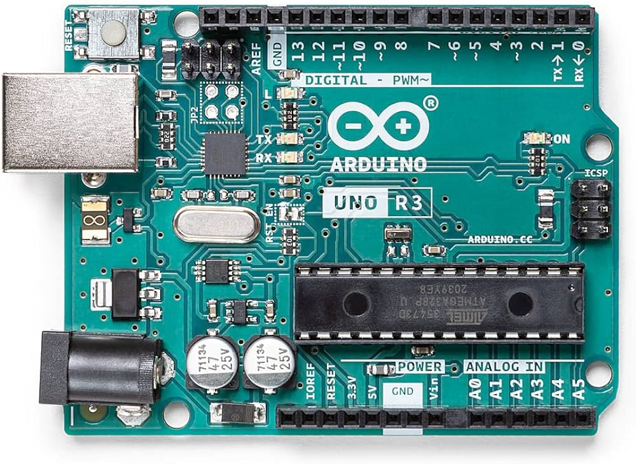
Figure 1. Arduino Uno

28BYJ-48 Stepper Motors (x3): These small and inexpensive stepper motors provide precise incremental motion control, making them ideal for driving the CNC machine's axes. Their specifications include a step angle of 5.625°/64, a voltage rating of 5V, a current rating of 100mA/phase, and a gear ratio of 1/64. These motors offer a good balance of cost, size, and performance for this project.

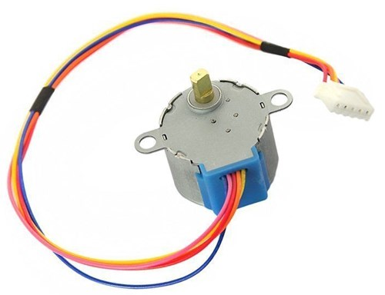
Figure 2. 28BYJ-48 Stepper Motors

ULN2003 Stepper Motor Drivers (x3): These driver modules provide the necessary current and voltage levels to operate the 28BYJ-48 stepper motors, ensuring smooth and reliable motion. They are designed to drive unipolar stepper motors with a maximum current of 500mA per phase, providing ample headroom for the 28BYJ-48 motors. The ULN2003 drivers are readily available and easy to interface with the Arduino Uno.

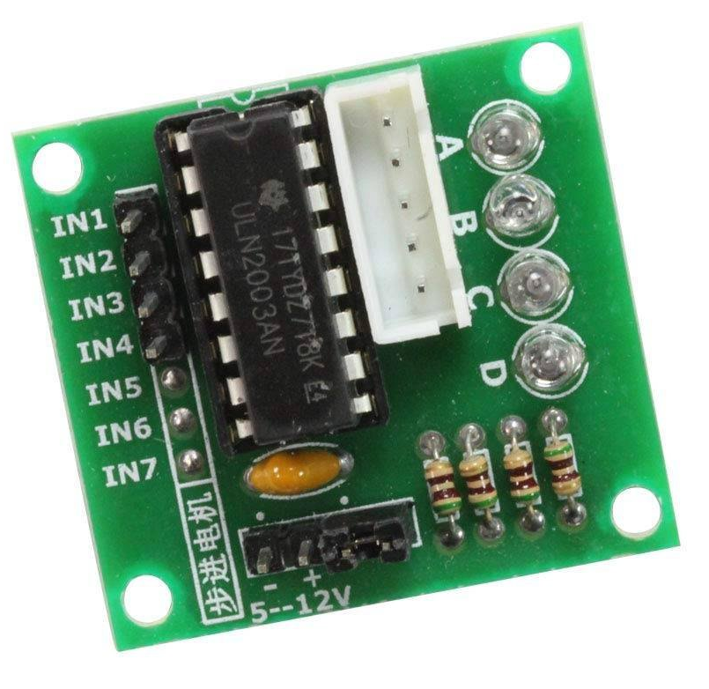
Figure 3. ULN 2003 Stepper Motor Driver

Wires: Various wires were used for connecting the components and establishing the electrical circuit. These included jumper wires, solid core wires, and stranded wires of appropriate gauge to handle the current requirements. The choice of wire type and gauge was based on the specific application and current carrying capacity needed.

5V 1A DC Power Supply Adapter: A DC power supply adapter was used to give external power supply to the system.

Screws (x10): Screws were used for securing the mechanical components and ensuring the structural integrity of the CNC machine. Different types of screws, such as M2 series were used depending on the specific application. The size and type of screws were chosen based on the materials being joined and the required holding strength.

Bearings: Bearings were incorporated to reduce friction and enable smooth movement of the CNC machine's axes. Linear bearings were used for linear motion, while radial bearings were used for rotary motion, depending on the specific requirements of each axis. The choice of bearings was based on factors such as load capacity, precision, and cost.

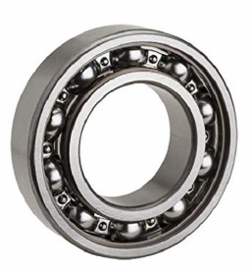
Figure 4. Bearing

3D Printed Parts: Custom-designed 3D printed parts were used to create the structural framework and mechanical components of the CNC machine, providing precision and adaptability in design. The 3D printing process allowed for the creation of complex shapes and intricate details that would be difficult to achieve with traditional manufacturing methods. The 3D printed parts were designed using CAD software and printed using a fused deposition modeling (FDM) 3D printer.

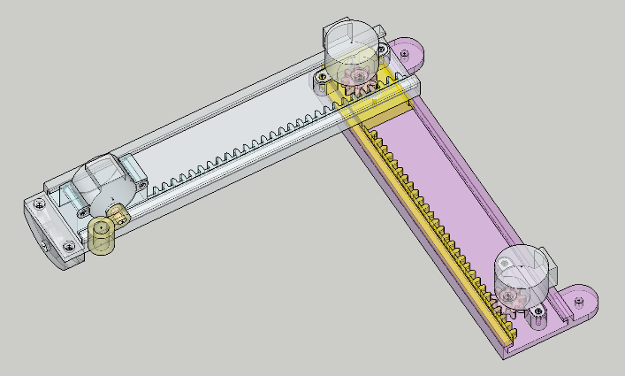
Figure 5. 3D CAD Model

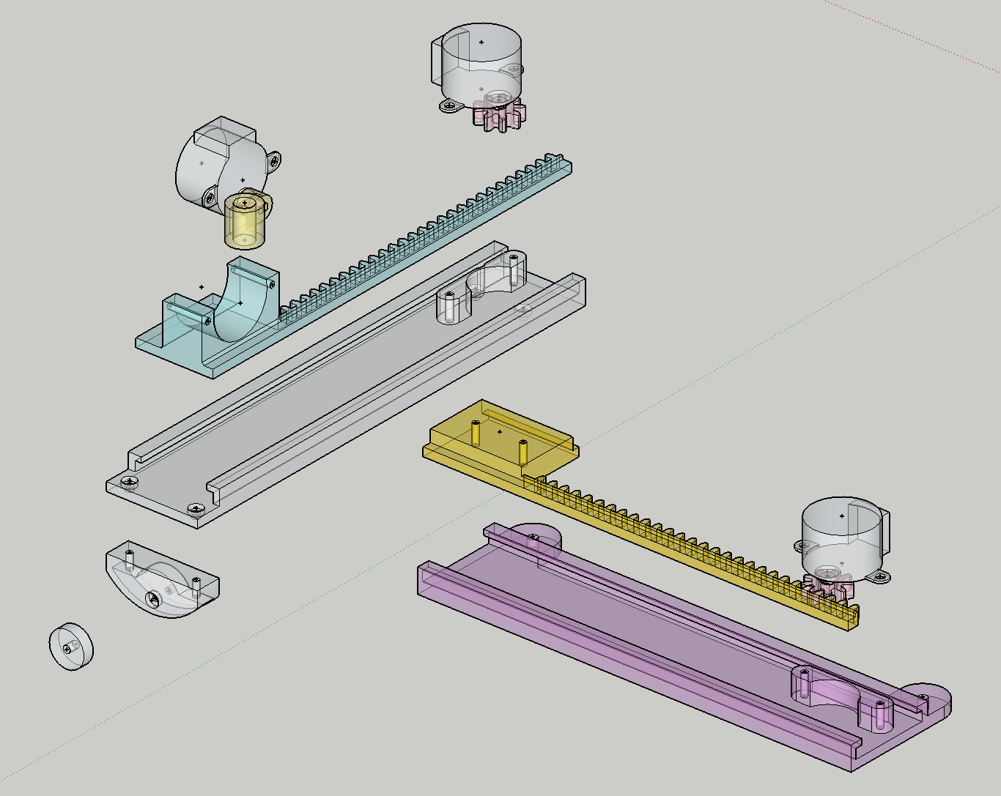
Figure 6. Parts of model
Wooden Base: A wooden base provides a stable and rigid platform for the CNC machine, minimizing vibrations and ensuring accurate operation. The wooden base was chosen for its affordability, ease of fabrication, and natural damping properties. The wooden base was cut to size and finished to provide a smooth and stable surface for the CNC machine.

- Software Components:
GRBL Library for Arduino IDE: GRBL is an open-source firmware for Arduino that interprets G-code commands and controls the stepper motors accordingly. It provides a robust and efficient platform for CNC motion control, offering features such as acceleration control, homing, and limit switches. GRBL is written in C++ and can be compiled and uploaded to the Arduino Uno using the Arduino IDE.

Inkscape Software: Inkscape is a free and open-source vector graphics editor used for creating or importing images and converting them into vector format, which is necessary for G-code generation. Inkscape offers a wide range of drawing tools and supports various file formats, making it a versatile tool for design creation.

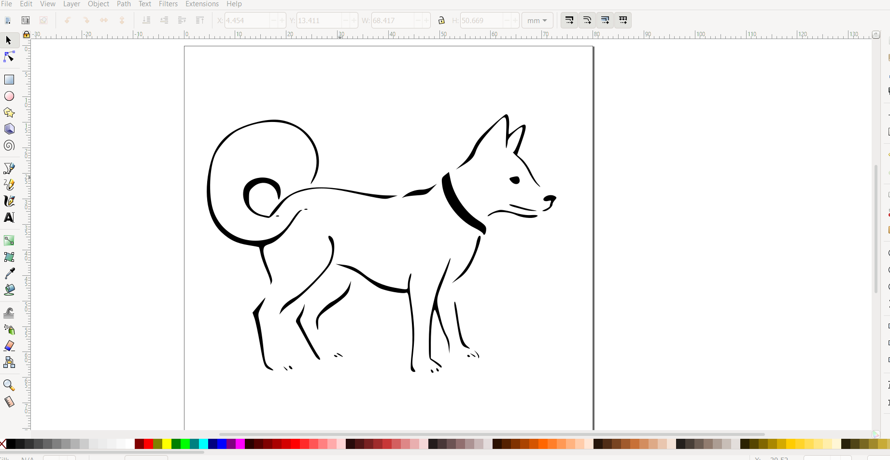
Figure 7. Inscape software interface
JScut Software: JScut is a software tool that processes vector images and generates the corresponding G-code, the standardized language for CNC machines. It enables the translation of design files into machine-readable instructions, offering various parameters for customizing the G-code generation process, such as feed rate, cutting depth, and tool diameter.

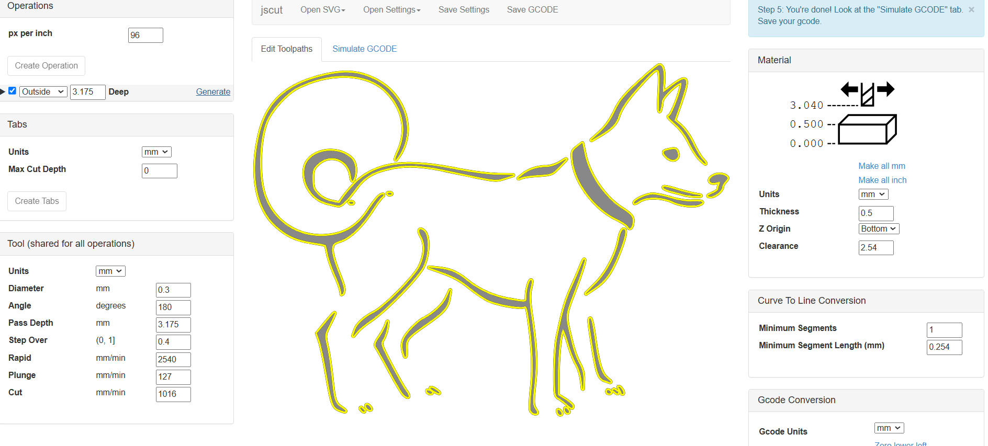
Figure 8. JScut Software Interface – Gcode generation

UGS (Universal G-code Sender): UGS is a user-friendly software application for sending G-code to the Arduino Uno, enabling the CNC machine to execute the desired motions. It provides a platform for communication and control of the CNC machine, offering features such as real-time monitoring and jogging control, and macro execution.

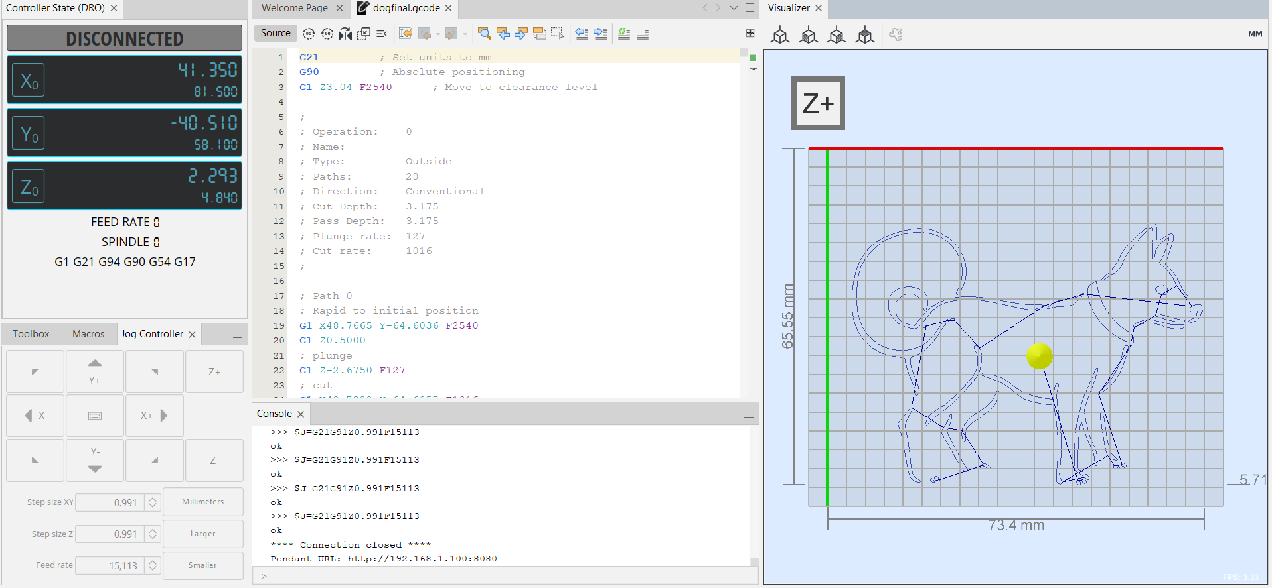
Figure 9. UGS Interface

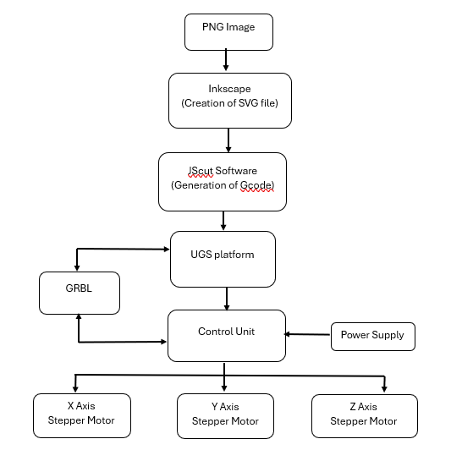
Figure 10. Block Diagram

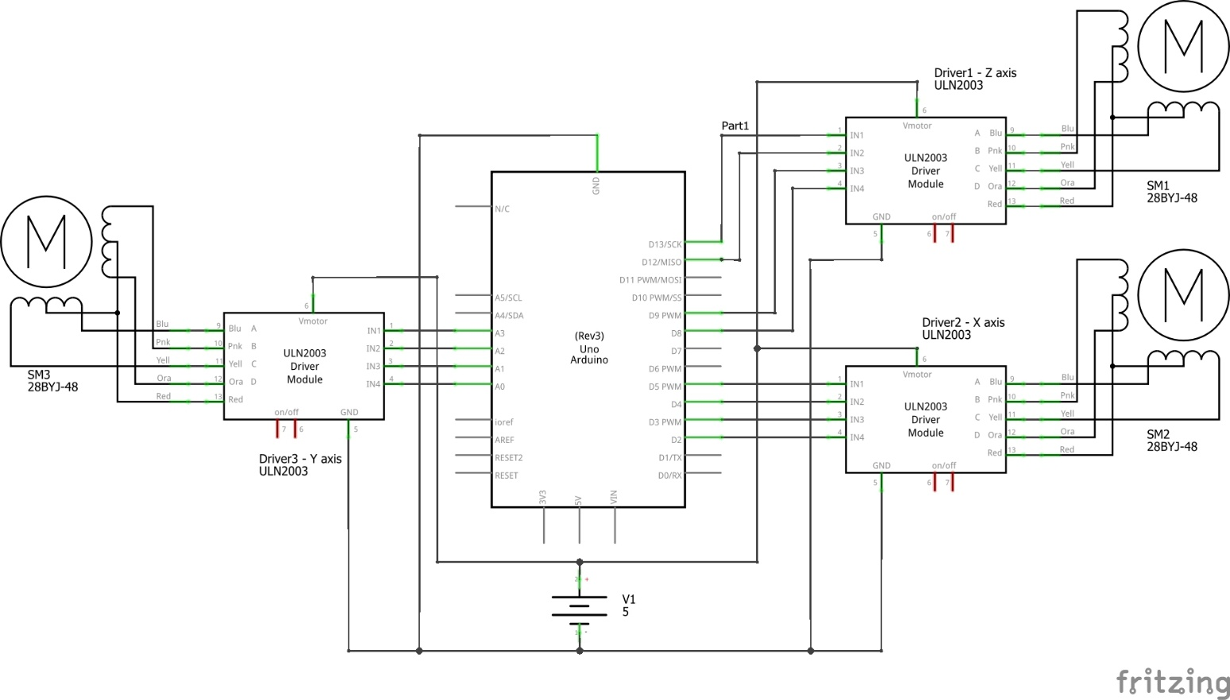
Figure 11 Circuit Diagram

- Circuit Design
The electronic design of the miniature CNC machine centers around the Arduino Uno microcontroller board. It serves as the brain of the system, receiving G-code commands from the computer and translating them into control signals for the stepper motors. The circuit diagram (provided separately) illustrates the connections between the Arduino Uno, the stepper motor drivers, and the stepper motors.

ULN2003 stepper motor drivers play a crucial role in controlling the stepper motors. These drivers function as intermediaries between the Arduino Uno and the motors, providing the necessary current and voltage levels to drive the motors effectively. Each driver is responsible for controlling one axis of motion (X, Y, or Z).

The Arduino Uno's digital output pins are connected to the input pins of the ULN2003 drivers. These digital pins send signals to the drivers, instructing them to step the motors in specific directions and at specific speeds. The drivers then amplify these signals and provide the necessary power to the stepper motors.

Each stepper motor has four connection points, corresponding to its four coils. These connection points are wired to the output pins of the corresponding ULN2003 driver. The drivers energize the motor coils in a specific sequence, causing the motor to rotate step

by step.

The power supply provides the necessary voltage and current for the Arduino Uno and motor drivers. The voltage level is typically 5V, which is suitable for both
the Arduino Uno and the 28BYJ-48 stepper motors. The current rating of the power supply should be sufficient to drive all three stepper motors simultaneously.

The circuit diagram also includes connections for limit switches (optional). Limit switches are sensors that detect the end positions of the CNC machine's axes. CNC machines can be used to prevent the machine from moving beyond its physical limits, protecting it from damage.

The electronic design of the miniature CNC machine is straightforward and easy to implement. The use of readily available components, such as the Arduino Uno and the ULN2003 drivers, makes it accessible to hobbyists and students. The circuit diagram provides a clear visual representation of the connections between the components, facilitating the construction and troubleshooting of the system.

- Results and Discussions

The developed miniature CNC machine demonstrated accurate and repeatable motion control, enabling the creation of basic patterns and designs. The use of 3D printed parts allowed for customization and adaptability, while the open-source software provided flexibility and ease of use. The system's low cost and accessibility made it suitable for educational and experimental purposes, providing a hands-on learning experience in CNC technology and robotics.

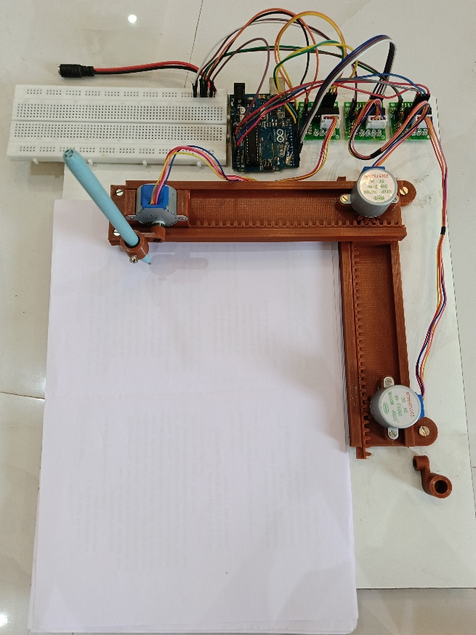
Figure 12 Actual Assembled Model

The miniature CNC machine was able to accurately reproduce various patterns and designs, including lines, curves, and geometric shapes. The precision of the machine was limited by the resolution of the stepper motors and the mechanical tolerances of the 3D printed parts. However, the machine was able to achieve satisfactory results for educational and experimental purposes.

The use of GRBL firmware provided a robust and efficient platform for CNC motion control. The firmware's features, such as acceleration control and homing, enabled smooth and precise movements. The open-source nature of GRBL allowed for customization and modification, providing flexibility for future development and experimentation.

The integration of Inkscape, JScut, and UGS provided a user-friendly workflow for designing and executing CNC operations. Inkscape's versatility allowed for the creation of various designs, while JScut's G-code generation capabilities enabled the translation of these designs into machine-readable instructions. UGS provided a convenient interface for sending G-code to the Arduino Uno and monitoring the CNC machine's operation.

One of the key advantages of this miniature CNC machine is its adaptability. The use of 3D printed parts allows for easy modification and customization of the machine's design to suit different applications. For example, the end effector can be replaced with a pen holder to create a drawing machine, or a small gripper can be added to perform pick-and-place operations.

The miniature CNC machine also serves as an excellent educational tool. It provides students with hands-on learning experience in CNC technology, programming, electronics, and mechanical design. By building and operating the machine, students can gain a deeper understanding of these concepts and develop valuable skills in problem-solving and critical thinking.

- Conclusion

This project successfully demonstrated the development of a miniature CNC machine using an Arduino Uno microcontroller and readily available components. The system's hardware and software integration, design considerations, and potential applications were discussed. The project achieved its objectives of creating a low-cost, adaptable, and educational CNC system for learning and experimentation.

The miniature CNC machine provides a valuable platform for students, hobbyists, and educators to learn about CNC technology, programming, electronics, and mechanical design. The use of 3D printing technology enabled customization and adaptability, while the open-source software provided flexibility and ease of use.

The machine's ability to accurately reproduce patterns and designs showcases its potential for both educational and practical applications. Its low cost and open-source nature make it accessible to a wide range of users, promoting wider adoption of CNC technology and encouraging further innovation in the field.

By successfully integrating hardware and software components, this project demonstrates the feasibility of creating a functional and versatile miniature CNC machine. This contributes to the growing trend of democratizing technology and making advanced manufacturing tools more accessible to a wider audience.

- References

[1] Groover, M. P. (2016). Fundamentals of modern manufacturing: materials, processes, and systems. John Wiley and Sons.
[2] Weihnacht, C., & Borchers, S. (2019). Open-source hardware for science and education. Journal of Open Hardware, 3(1), 6.
[3] Gibbons, P. (2014). The rise of the desktop CNC machine. Forbes. Retrieved from https://www.forbes.com/sites/petergibbons/2014/09/28/the-rise-of-the-desktop-cnc-machine/
[4] Xu, X., & Wang, L. (2019). A review of CNC machining technology. International Journal of Precision Engineering and Manufacturing-Green Technology, 6(4), 673-687.
[5] Land, M. H. (2013). Full STEAM ahead: The benefits of integrating the arts into STEM. Procedia Computer Science, 20, 547-552.
[6] Pabolu, V. K., & Shrinivas, K. N. H. (2010). Design and implementation of a three-dimensional CNC machine. International Journal of Computer Science and Engineering, 2(5), 2567-2570.
[7] Nae, I., & Andrei, T. (2010). Designing and building a CNC router using stepper motors. Serial Technical, LXII, 55-62.
[8] Pahole, I., Rataj, L., Ficko, M., Klancnik, S., Brezovnik, S., Brezocnik, M., & Balic, J. (2009). Construction and evaluation of low cost table CNC milling machine. Scientific Bulletin, Series C: Mechanics, Tribology, Machine Manufacturing Technology, XXIII, 1-7.
[9] D'Ausilio, A. (2012). Arduino: A low-cost multipurpose lab equipment. Behavior research methods, 44(2), 305-313.
[10] Di Prima, S. (2015). Automated single ring infiltrometer with a low-cost microcontroller circuit. Computers and Electronics in Agriculture, 118, 390-395.
[11] Mohammed, M. N., Nadarajah, V. S., Lazim, N. F. M., Zamani, N. S., Al-Sanjary, O. I., Ali, M. A. M., & Al-Youif, S. (2018). Design and Development of Pipeline Inspection Robot for Crack and Corrosion Detection. In 2018 IEEE Conference on Systems, Process and Control (ICSPC 2018) (pp. 29-32). IEEE.
[12] Mohammed, M. N., Ghanesen, Y., Al-Sanjary, O. I., Ali, M. A. M., Zamani, N. S., & Al-Zubaidi, S. (2019). Investigation on Carbon Monoxide Monitoring and Alert System for Vehicles. In 2019 IEEE 15th International Colloquium on Signal Processing & its Applications (CSPA 2019) (pp. 239-242). IEEE.
[13] Mohammed, M. N., Radzuan, W. M. A. W., Al-Sanjary, O. I., Ali, M. A. M., Raya, L., & Al-Zubaidi, S. (2019). Study on RFID Based Book Tracking and Library Information System. In 2019 IEEE 15th International Colloquium on Signal Processing & its Applications (CSPA 2019) (pp. 235-238). IEEE.
[14] Zamani, N. S., Mohammed, M. N., Abdullah, M. I., & Al-Zubaidi, S. (2019). A New Developed Technique for Handwriting Robot. In 2019 IEEE International Conference on Automatic Control and Intelligent Systems (I2CACIS 2019) (pp. 267-270). IEEE.

[15] Ďurina, D., Petrovič, P., & Balogh, R. (2006). Robotnačka - The Drawing Robot. Acta Mechanica Slovaca, 2-A, 121-126.

